***Introduction Hometask***

1. Activate you MSDN Azure benefit

1. Create Windows VM: [Create a Windows virtual machine in Azure](https://docs.microsoft.com/en-us/learn/modules/create-windows-virtual-machine-in-azure/)

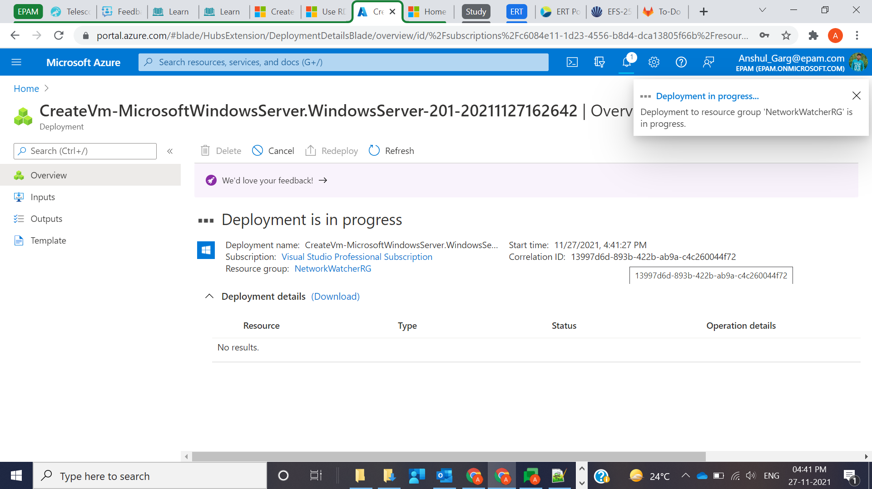

1. Optional (create Linux VM): [Create a Linux virtual machine in Azure](https://docs.microsoft.com/en-us/learn/modules/create-linux-virtual-machine-in-azure/)

